HemoSim edit doc - N7-Topic1-Indications
HOW TO USE: edit the wording directly (Track Changes if you like). For layout or a figure (size, position, wrong/missing image) write a short instruction in [brackets] right where it applies. Send it back and I apply the wording to the page and the layout notes to the styling, then regenerate. This is a content+notes doc, so it will not look exactly like the web page.
[note: I started tracking changes after making changes in the first 2 paragraphs. Accept all changes in the first two paragraphs even if they are not tracked.]

Indications, anatomy, and setup
The pulmonary artery catheter is a balloon-tipped venous catheter that floats into the pulmonary artery and reports pressures from the right heart, a stand-in for left-heart filling, and cardiac output. Using it well starts by knowing when it is indicated, what its numbers really mean, and how the setup makes those numbers trustworthy.

When it is indicated
There are no absolute, must-place indications. The catheter earns its place when the hemodynamic question is genuinely unclear: undifferentiated or multifactorial shock, monitoring cardiac function during and after cardiothoracic surgery, guiding treatment in advanced cardiogenic shock, sorting out and optimizing right heart failure and pulmonary hypertension (where right heart catheterization is the gold standard for diagnosis), sampling mixed venous oxygen saturation, and titrating mechanical circulatory support.
It is also important to recognize the limits of a PA catheter. The catheter gives static filling pressures, which do not in and of themselves predict fluid responsiveness. There is no single cardiac output or resistance number to chase, since an index that is fine for one patient leaves another in shock. Randomized trials show no mortality benefit, but more recent observational data suggests that use of PA catheters to guide care in certain populations is beneficial. The value is diagnostic clarity in the right patient, not a target to treat.

When not to place one
Some anatomy makes placement more difficult, changing the relative risk of harm caused by catheter placement. A tricuspid or pulmonic prosthesis, a valvular vegetation, or a right-sided mass or clot should lead to reassessment of the true risk:benefit of catheter placement. An existing left bundle branch block (LBBB) deserves special caution since catheter placement often provokes a transient right bundle branch block as it crosses the right ventricle. In a patient who already has a LBBB, this can result in unintended complete heart block. While an existing LBBB does not preclude PA cathether placement, it does suggest that equipement for emergent pacing is readily available during placement.
Most other problems come from the line itself (infection, thrombus), so plan to remove the catheter as soon as possible. Leaving a line in without acceptable reason is dangerous and frequently leads to unintended, harmful consequences.

The complication to respect
The complication to respect most is pulmonary artery rupture. While exceedingly rare the complication carries a very high risk of fatality should it occur. The habits that prevent it are simple and non-negotiable
- Watch the waveform during balloon inflation and stop the moment the wedge tracing appears
- Never inject more than 1.5 mL of air into the balloon.
- Never inject fluid through the balloon port
- Never leave the balloon inflated for a prolonged period of time (more than about fifteen seconds), and let the balloon deflate passively.

Know the catheter by its ports
The catheter is easiest to learn by its lumens. Most are quadruple-lumen, and the color tells you the job:
Port | Color | Ends at | Use
Proximal infusion | White or clear | 31 cm, right atrium | fluids and drugs
RA / injectate | Blue | 30 cm, right atrium | RA (CVP) pressure; injectate for cardiac output
Distal / PA | Yellow | tip, pulmonary artery | PA pressure and mixed venous sampling
Thermistor | Red | ~4cm from distal tip | senses temperature for thermodilution
A balloon surrounds the tip. The syringe for inserting air into the balloon usually withdraws to a maximum 1.5 mL, which is the built-in safety limit. Also note the dashes along the outside of the catheter itself. Thin markings on the catheter represent 10 cm. increments of depth. Thicker markings represent a 50cm depth increment.
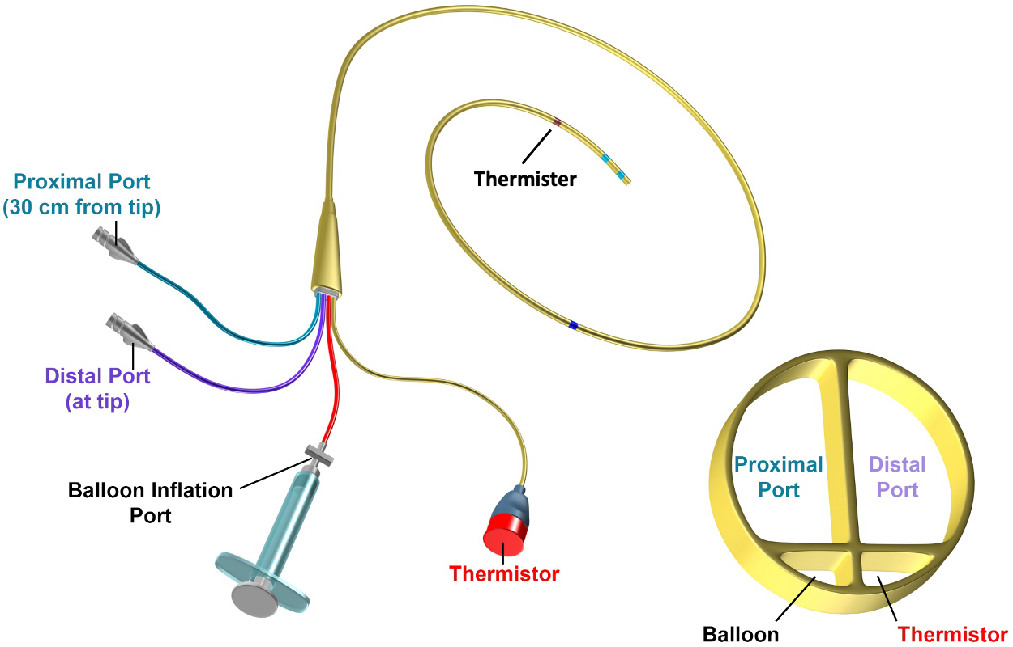
[Insert the image above and the following caption below it: “The quadruple-lumen catheter: a distal (PA) lumen at the tip, a proximal (RA) lumen, a thermistor 4 cm from the tip, and the balloon inflation port. “]

Zero and level before you trust a number

Before any pressure means anything, the transducer has to be zeroed to atmospheric pressure and leveled to the phlebostatic axis. Level it even a few centimeters off and every pressure afterward is wrong. Run a trifurcated, pressurized saline bag at 300 mmHg, transduce the RA (blue) and PA (yellow) lines continuously so you catch an unintentional wedge or a drop back into the ventricle. For reference, the normal values you are checking against:
Site | Normal pressure
RA / CVP | 2 to 6 mmHg
Right ventricle | 15 to 25 / 2 to 6 mmHg
Pulmonary artery | 15 to 25 / 8 to 15 mmHg (mean 10 to 20 mmHg)
Wedge (PAOP) | 6 to 18 mmHg
Cardiac index | 2.5 to 4 L/min/m2
[FIGURE PLACEHOLDER - to import at build: Figure placeholder · PA catheter components (balloon, lumens, thermistor) from Dropbox: Hemodynamics Module v2022 Full, slide 249]
[This section should be broken into two separate sections. The first on zeroing and the second on leveling. For the zeroing section, provide an in-depth physiologic explanation of why zeroing is important. You may need to consult alternate sources on the web for this if my internal sources are insufficient. Then provide an in-depth explanation of how to zero the catheter. I have a video how to manipulate the stopcock so the transducer assembly is exposed to atmospheric pressure that I will include, so provide a placeholder for that.
The second section should explain why leveling is important – the concept that the phlebostatic axis represents, by convention, a point of zero reference for the transducer. Feel free to use '/Users/chaissn/Library/CloudStorage/Dropbox/CCF 2026 transfer/Pulmonary Topics/Pulmonary Topics/PULM HYPERTENSION/PA Catheter Grand rounds 2024-2.pptx', slides 24-27 in addition to other resources on the web or Dropbox:Hemodynamics Module v2022 Full slides 246-269.]

[No references this section]

